**Biography on John Carmack**

For this assignment, I decided to do a biography on John Carmack, an American software engineer best known for his advancements of 3D graphics in gaming and his role as CTO at Oculus VR.



Over the past 25 years the gaming industry has progressed immensely due to innovation and customer demands. Carmack developed and popularised the use of many techniques in computer graphics such as *Adaptive tile refresh*, *raycasting* and *surface caching.* These techniques are the building blocks to many of the games I played as a child and still play today.

The engines Carmack has developed have been licensed for use in award winning first-person shooters Half Life, Call of Duty and Medal of Honour. For anyone who grew up playing these games, we are indebted to Carmack. Half Life was the first video game I ever played, and during my years in secondary school, Call of Duty acted as a social platform for myself and my friends to play together and chat online. I believe Carmack’s innovation and engineering led the way in the gaming industry and as a result, today the US gaming industry alone is estimated to be worth $23.5 billion dollars.

**Work**

Carmack started his career in Louisiana with a company called *Softdisk*. It was there that himself and his fellow team members created the first of the *Commander Keen* games in 1991. After this, he left *Softdisk* and co-founded *id Software.* It was from this point that Carmack began programming software that would have impact the future of the gaming industry drastically.

*Adaptive tile refresh*

Carmack engineered *adaptive tile refresh* for use in the game *commander Keen*(pictured below). Before *adaptive tile refresh* was developed, every frame of a side scroller game would have to be redrawn with each movement. PC’s at the time did not have the computing power at the time to be able to perform this so when Carmack developed *Adaptive tile refresh,* it allowed side scroller games to be played on PC’s for the first time ever. Rather than the whole screen being redrawn every time, only the edges were redrawn which was much more efficient.

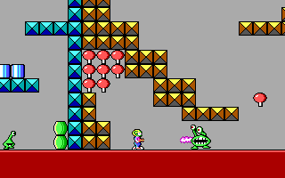

*Quake Engine*

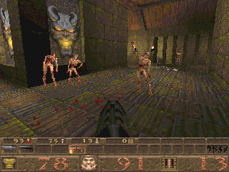

Carmack co-developed the engine for the game Quake which was released in 1996. Carmack was the first to use *Binary space partitioning* in computer graphics and he also invented *surface caching* for this engine too. These techniques led to Quake offering full real-time 3D rendering. Today real-time 3D rendering appears in almost every video game and this is down to the influence and advancements of the Quake engine Carmack created. This game also popularised online multiplayer modes (Deathmatches etc.) which are now a massive part of gaming which we can see from games such as Call of Duty and Counter Strike where millions of gamers play multiplayer online every day.

Oculus VR

In August 2013, Carmack resigned from id Software and took up the role of CTO at Oculus VR. Oculus VR are a company that specialises in virtual reality hardware and software. Once again Carmack is at the front of computer graphics and gaming development as virtual reality is a new and innovative style of gaming. Until now, Virtual reality gaming has always been rather poor and undeveloped, but Oculus and Carmack have created hardware and software that may lead to virtual reality gaming becoming popular worldwide.

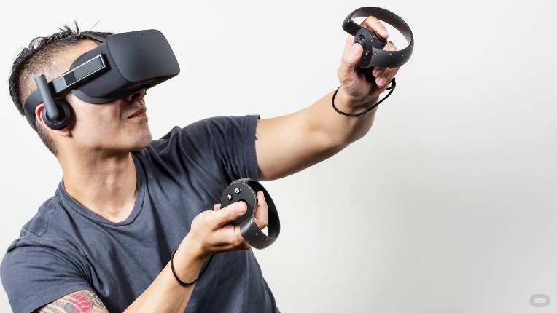

Carmack engineered software for the *Oculus rift,* a virtual reality headset (shown above) which was released in 2016. This product incorporates player motion which adds to the realism of the game which they are playing. Carmack has always been committed to improving the gaming experience and Oculus VR is the next step in doing so.

Without the software techniques and programs Carmack created, I strongly believe there wouldn’t have been such an advancement in gaming and computer graphics. He paved a way for all game developers to follow and it is gamers like myself that have reaped the rewards from this. Popular games today such as *Call of Duty*, *Skyrim* and *The last of us* all use fundamental programming techniques created and popularised by Carmack. I admire Carmack for his continuous efforts to innovate and develop technology in the gaming industry. The fact that he took the position in Oculus illustrates his continuous aim to improve technology in the gaming industry.

Since 1990, Carmack has been an icon in the game development world and has continued to innovate and develop technology to give us gamers the best experience possible. From *Commander Keen,* to *Quake* and now to Oculus VR, Carmack has been, and still is, at the forefront of game development and computer graphics.

**Sources**

Wikepedia

<https://en.wikipedia.org/wiki/John_Carmack>

google images

<https://www.google.ie/search?q=john+carmack&rlz=1C1CHBF_enIE728IE728&source=lnms&tbm=isch&sa=X&ved=0ahUKEwix6OP03sXXAhWJYVAKHQWFABEQ_AUICigB&biw=1707&bih=735>